October 24, 2007

Ginsborg uses her account of the self-referentiality of taking something to be beautiful, and that idea of normativity, to generate a generalized account of concept acquisition.

This is interesting in relation to the problem of abstraction – i.e., when judging an object reflectively (when I do not know the universal of which it is an instance), how do I know what features of that object to pick out, so that I can look for resemblances between it and some other objects?

The notion of schema doesn’t answer this question.

Longuenesse says that we are always heading towards universality, because we are always trying to make the object fit within our judgement, but that just begs the question: which features, and why?

Ginsborg’s general strategy is to combine a Humean dispositional account with a Kantian normative account.

She says: when we perceive an individual object, it is a basic psychological fact about us that our association of ideas follow certain regular patterns. When we see a triangle, we think of other triangles we have seen. We automatically remember resemblances. This is a primitive fact about how the imagination works.

And because of natural patterns of association, once the word “triangle” has been applied to a representative sample, we will become disposed to apply it to triangles generally. And relatedly, when we entertain hypotheses involving the word “triangle,” it is precisely ideas of triangles that we are supposed to call to mind as potential counterexamples. Finding a resemblance does not precede the acquisition of the corresponding disposition. Rather, acquiring the disposition is just what finding the resemblance consists in.

Resemblance is a consequence of association and not a condition for it.

This is a version of psychological nominalism. She needs to say something more: why should the representational character of a particular idea be transformed by a state of readiness to call to mind other particular ideas into a universal norm? Why does that count as generality at all?

She adds: the awareness of one’s own state of readiness – rather than the particular idea itself – is what constitutes the possession of the general idea. I.e. it is my attitude towards this idea – my own state of readiness to think of it as a general idea – that makes it a general idea.

That is, generality is equal to my readiness to call to mind like objects and conceive of them as having normative force.

The normative twist:
My perception of a tree not only involves my being in a state of readiness to call to mind (reproduce) representations of other trees, but my taking it that, insofar as I do call other ideas of other trees to mind, I am doing what I and everyone else ought to be doing under these circumstances. That is, the generality of my disposition lies not in the rules and not in the content, but is incorporated into my perception, through seeing the tree as a tree, in virtue of my awareness that my readiness to associate this tree with other trees is appropriate given my perceptual situation.

The rule-governedness or generality in my associations is not a function of the rules themselves, but of my taking my representations to be rule-governed.

This is exactly what she said about beauty.

This is what makes beauty interesting: Kant wants to make room for the possibility of normative claims that do not presuppose existing rules. This is his anti-Platonic move. And his way of handling this is that our entitlement to make judgements of beauty appears to depend on our being entitled to take a normative attitude towards our mental activity generally.

Ginsborg has a 4-part theory of concept acquisition:

- We are hardwired to form dispositions to associate x (one perception) with previous x’s (morphologically like perceptions).
- As a second thesis, I would add that we have cultural/anthropological constraints on the way we pick out objects (what objects are your parents showing you?).
Cavell: rule-following depends on us sharing a world (things we all need, things we all find interesting) – that the world appears the way it does is overdetermined by evolution and culture making certain objects salient in our environment. This is going to govern our disposition to association.

So far, all of this is completely empiricist – a version of Hume.

- The normative twist: When I form such a disposition, I take it that my disposition is as it ought to be. The generality derives not from the association, but from my giving those associations the standing of seeing things as they ought to be seen.
- What follows is that I can only cash out my belief in (3) by forming two kinds of rules:
  - schema rules
  - rules of inference

The implication of (3) is to take there to be a schema to umbrellas, say, and rules for inferring that something is an umbrella.

Rule-following and schema formation are thus the last step in a developmental sequence.

The great question of normativity is answered by the self-referential thesis, and then only gets made explicit by the series of rule-following activities.

(3) (4?) can only kick in if beauty is possible – if there are cases of normativity not underpinned by (already existing) rules.

Normativity is the hinge between the empiricism and the rule-following here.

the third moment: PURPOSIVENESS

The Third Moment:

- Disinterestedness
- Universality
- Purposiveness

About the character of the object suitable for a universally communicable state of the harmony of the faculties. Not talking about the object itself, but the object qua represented in mere reflection.

p. 236

“Beauty is an object’s form of purposiveness insofar as it is perceived in the object without the presentation of a purpose.”

i.e. Purposiveness without purpose.

§10 Purposiveness is originally thought of as a property of a concept having a causality with respect to its object, and the object is thought of as a purpose.

So, my concept of dinner tonight is purposive in the sense that it will lead me to produce a dinner, and that dinner is the purpose. When we look at that dinner, we think that is not a cosmic accident, but the consequence of an intentionally planned act. It has been achieved through someone’s conceptuality.

That gives us the notion of the purposiveness of a concept and gives us a content – the object produced.

But our concern here is with aesthetics. And so Kant says, (end of §10)

On the other hand, we do call objects, states of mind, or acts purposive even if their possibility does not necessarily presuppose the presentation of a purpose. We do this merely because we can explain and grasp them only if we assume that they are based on a causality that operates according to purposes, on a will that would have so arranged them in accordance with the presentation of a certain rule.

Sometimes we are struck by objects – both cultural and natural objects – that, because of the intricacy of their form or arrangement as we experience it, we cannot but think of them as the consequence of – let’s call it – intelligent design, even if we have no idea what they were designed for.

We can perceive a purpose merely on the basis of form.

What is form here? The purposive look of something independent of our capacity, or even desire, to construe it as an actual purpose.

It is purpose without a content.

For reflective judgement, all purposiveness is without purpose, since logically judging purposiveness would be making a determinate judgement. For the sake of aesthetics, we want purposiveness without a purpose.

In §11, Kant argues for this purposiveness without purpose by arguing by elimination from all the other possible grounds for our liking an object. Since we get disinterested pleasure from the object, then it has no subjective purpose. Furthermore, it has no objective purpose (i.e. morality), and because it’s aesthetic it’s not based on a concept. “Therefore, the liking that, without a concept, we judge to be universally communicable, and hence to be the basis that determines a judgement of taste can be nothing but the subjective purposiveness in the presentation of an object, without any purpose, whether objective or subjective, and hence the mere form of purposiveness, insofar as we are conscious of it in the presentation in which an object is given to us.”

Why is he talking about purposiveness at all?

1. The form of purposiveness is the seeming-as-if-designed. (Later he will say that when we look at nature, we conceive it as art – that is, it has the look of something designed – and artworks must have the look of something natural – not explicitly intended.)

Purposiveness is introduced into the analysis of a universally communicable pleasure in a mental state of the free harmony occasioned by reflection upon an object, which entails that it is mentally, subjectively purposive, not because of its form, but because it enhances the reciprocal activity of the imagination and understanding.

The object construed as purposive here, is only purposive as apprehended, for the harmony between the imagination and the understanding. Recall that in this section (§10) that Kant states that “consciousness of a presentation’s causality, directed as a subject’s state, so as to keep it in that state, may here designate what we generally call pleasure.”

So it is purposive for keeping us in that harmonic state, and that is the source of pleasure, and that pleasure occurs because being in that state is generally purposive for cognition.

Purposiveness is being used in three ways:
- a form of purposiveness
- for the sake of the relationship between the imagination and the understanding – it keeps them in that state of pleasure
- that state of harmony matters to us (§21) because being in it is propadeutic to cognition in general

An aesthetic state will be pleasurable because purposive – not purposive because it produces pleasure. That is, it’s only those states that are purposive without a purpose, that produce pleasure. And it’s not the fact that we have the pleasure that leads us to think of those states as purposive.

So, purposiveness is really seeming-purposive. Purpose-like. Which occurs when not connected to a determinate purpose. Hence Kant’s notion of a form of purposiveness.

Lyotard, “Sensus Communis” Judging Lyotard ed. Andrew Benjamin

A judgement blind to every end, but for this very reason not a symptom, or as Kant says, ‘disinterested’ – without interest in liberty or in pleasure in the usual sense; a state of mind that owes nothing as yet (or already no more) to the intrigues of willing, whatever it be – this feeling, when it is a question of tasting beauty, is precisely a feeling of pleasure. But a pleasure with doesn’t come to fill up a lack, nor to fulfill any desire at all. A pleasure before any desire. The aesthetic pleasure is not the purpose of a purposiveness experienced beforehand as desire. It has nothing whatsoever to do with an end or purpose. It is finality. Purposiveness itself, which has no end, no purpose in front of it, nor lack behind it.

So that notion of purposiveness without purpose is also pleasure without desire. You cannot have disinterested pleasure – pleasure without desire – without purposiveness without purpose.

On the occasion of a form, which is itself only an occasion of feeling, the soul is seized by a small happiness, unlooked for, unprepared, slightly dynamizing. It is an animation, or an anima, there on the spot, which is not moving towards anything. It’s as if the mind were discovering that it can do something other than will and understand. Be happy without ever asking for it, nor conceived it – an instant which will seem very long measured by the clock of intrigue, but which is not in the purlues of its timekeeping. A flash made of glades.

Only in aesthetic movements do we subvert the metaphysical will to truth – do we get out of the structure of lack and fulfillment that transpires either as the belief in the true or the good, and of course which ends up as rationalism and totalitarianism.

Aesthetic moments open up a relationship to ourselves and to the world that is not structured by a finality. If one thinks that the structure of finality is what we mean by metaphysics (everything has an end or purpose – the structure of finality always leads to god), then the only way to begin to think of a world without a god is by the moment of the beautiful.

So to take purposiveness without purpose, in terms of natural beauty, is to expose us to a nature that is theologically disenchanted, but humanly inhabitable (as if, perhaps, for the first time). Perhaps before Kant no one had conceived of nature in human terms, as opposed to theological terms.

And yet, all this is bound up with Kant’s formalism – that we experience works of art and nature in terms of form, not content. Purposiveness without purpose is what he means by form here.

So what does he mean by form? How are we to interpret Kant’s so-called restrictive formalism?

§14 “Elucidation by examples”

about the critique of colour and taste

Trying to make precise what the proper object of aesthetic regard is.

It cannot be a mere empirical liking – people will declare a mere colour or tone to be beautiful in itself. Kant must resist this, because a uniform colour or tone can only be experienced causally.

He wants thus to reintroduce Hume’s distinction between primary and secondary qualities. The first can only be known by one of our senses. The only proper objects of aesthetic regard are those that can be experienced by more than one sensory apparatus.

The critique of charm is a critique of sensation – and the role of sensation in art, and a restriction of art to judgements of form.

So it looks as if what he means by form is nothing more than spatio-temporal organization.

Hence Kant seems to argue that true art depends on design in composition, as opposed to anything directly sensory.

p. 225

In painting, in sculpture, indeed, in all the visual arts, including architecture and horticulture insofar as they are fine arts, design is what is essential; in design the basis for any involvement of taste is not what gratifies us in sensation, but merely what we like because of its form… All form of objects of the senses (the outer senses, or, indirectly, the inner sense as well) is either shape [space] or play [time].

This is clearly wrong.

Guyer: “Form” really is a dummy term for whatever occasions harmony between imagination and understanding – whatever has enough complexity to generate a relationship between them.

Allison: If form is ordering an arrangement of data as taken up by imagination so that complexity and unity are necessary elements, Kant conflates perceptual form and aesthetic form. Allison quotes a passage from Kant’s Anthropology from a Pragmatic Point of View where this conflation is explicit (p. 137 in Allison) “‘But in taste, that is in aesthetic judgement, what produces the pleasure in the object is not the sensation immediately – the material element in our idea of the concept – it is rather the way in which the free and productive imagination arranges the matter inventively – that is, the form. For only form can lay claim to a universal rule for the feeling of pleasure. We can expect no such universal rule from sensations, which can differ greatly as the subjects differ in their attitude in the senses.”

But that passage tells you exactly why perceptual form won’t do. Perceptual form, having to do with space and time, is rule-bound. We are back into objectivity.

In Chapter 3 of his book The Idea of Form, Rudoplph Gasché argues that §14 is being misread, because the notion of elucidation by examples is really trying to ratchet up the concept of form by engaging with existing discourse in the arts. Kant is there trying to use the type of distinctions that belong to the art criticism of the time. But Kant cannot mean that it’s a spatial form, or organized temporality in the ordinary sense, that he is interested in, because Kant says over and again (in this chapter and later on) that too much regularity / symmetry / visible order are prohibitive of beauty. Because we experience order and regularity as constraints that do not allow for the free play of the imagination. Quoting Gasché (p. 66)

Neither regularity and symmetry nor their opposites constitute the beautiful form. Instead, a certain richness of the form itself, its indeterminateness or dunamis of possibilities constitutes that beauty. Rather than being opposed to content, form in this sense gestures towards what is otherwise than form and content – an exuberance of indeterminateness prior to any fixing of objective meaning and its constraining formal characteristics.

He refers us to Kant’s account at the very end of the chapter (p. 243, §22)

Everything that [shows] a stiff regularity (close to mathematical regularity) runs counter to taste because it does not allow us to be entertained for long by our contemplation of it; instead it bores us, unless it is expressly intended either for cognition or for a determinate practical purpose. On the other hand, whatever lends itself to unstudied and purposive play by the imagination is always new to us, and we never tire of looking at it. Marsden, in his description of Sumatra,

– there are all kinds of examples of primitive peoples here because Kant is interested in the notion of the wild and the primitive; that is a subtext of the entire discussion –

comments that the free beauties of nature there surround the beholder everywhere, so that there is little left in them to attract him; whereas, when in the midst of a forest he came upon a pepper garden, with the stakes that supported the climbing plants forming paths between them along parallel lines, it charmed him greatly. He concludes from this that we like wild and apparently ruleless beauty only as a change, when we have been satiated with the sight of regular beauty. And yet

– this is Kant’s defense of wildness –

he need only have made the experiment of spending one day with his pepper garden to realize that, once regularity has prompted the understanding to put itself into attunement with order which it requires everywhere, the object ceases to entertain him, and instead inflicts on his imagination an irksome constraint; whereas nature in those regions, extravagant in all its diversity to the point of opulence, subject to no constraint from artificial rules, can nourish his taste permanently. Even birdsong, which we cannot bring under any rule of music, seems to contain more freedom and hence to offer more to taste than human song, even when this human song is performed according to all the rules of the art of music, because we tire much sooner of a human song if it is repeated often and for long periods.

So, Gasché’s thesis is that beauty is not, as we might have been thinking of it all along, all this harmony of the imagination and understanding. It seems as if Kant would want a moment of dissonance – a certain disabling of the understanding, a making of understanding inadequate to the task, exposing the possibility of a free play of the imagination and understanding. Hence beauty is always – not form – but the excess of form. The form of all form. Form before it is ruled and governed. The possibility of form, rather than form itself. It is this exuberance of form that Kant thinks of as beautiful, and hence as what enables the beautiful.

The beautiful is not, and cannot be, the imagination and the understanding discovering, for any conceivable object, that they can put themselves into harmony, for if the object is sufficiently regular or structured or symmetrical, then there will be no play – no freedom – and hence no beauty.

Beauty is the condition for the possibility of cognition, or the relationship between the imagination and the understanding that are a condition for cognition, in a state that disallows cognition.

Interestingly, as he pursues this argument, Gasché nonetheless goes along with a standard reading of Kant: that the state of free play between imagination and the understanding is a precognitive state. The relationship between the imagination and understanding is the subjective side of objective conditions for cognition.

p. 81

The relationship between imagination and understanding represent the minimal relation necessary for there to be a possible cognition… Mere form, then, is the pre-objective and pre-predicative condition under which empirical manifold of imagination can be gathered into figures of objectivity in the absence of determinate concepts.

The puzzle is exactly there in this chapter by Gasché. The question is, what is the relationship between the claim that this is the minimal necessary condition for a cognition (the pre-cognitive, pre-predicative state that is the anticipation of cognition in general) and his thesis that this object, as apprehended, must be experienced as an excess of form, as wild form. There seems to be a tension between the minimalist account that wants to connect aesthetic pleasure to cognition in general, and the idea that what we experience in beauty is an exuberance of form – a form that exceeds the possibilities of ready cognitive grasp, and it is this exceeding of those possibilities that sets off the free play.

We will see that Kant consistently holds both theses – Gasché is not misreading Kant.

[32:25]

Question: It seems that the purposiveness without purpose is likewise an excess of purpose.

Absolutely. It’s form without form. By which I mean the difference between aesthetic form and perceptual form. Gasché is right to say that there has got to be a difference between the two. Perceptual form will be cashed out in the rule-governedness of the object, while aesthetic form is subjectively related, and is about the excess of that possibility of projecting back a series of rules onto the object. It is only in the relation of the imagination and the understanding, in their free play, that I experience the unity in the complexity. That’s what the beautiful is.

Question: I’m wondering about the section where he says that we can receive colour aesthetically. Even though it is normally just a sensation.

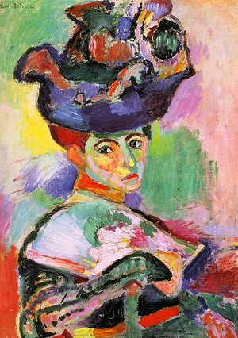
As I said he had to be wrong about that. And that is also why Euler was a problem for him, because Euler had a undulatory – that is, a wave-theory – of colour, such that Euler did not think that a colour was one monotonous tone, so to speak, and Euler’s account of colour just rode roughshod over Kant’s form-content, sensation-space-time structure. And Kant didn’t know what to do with it. Kant misread Euler because he was conflating the perceptual and the aesthetic. Once you stop that conflation… – what is Matisse’s greatest achievement? That he learned to draw in colour. He overcame the duality between drawing and colour, the traditional view of drawing as the substructure of the painting, and colour as filling in the dots, which Kant went along with. Matisse overturned 2500 years of thinking about art in just one picture.

[38:55]

Question: Is it possible for someone to say something beautiful just because they don’t understand the concept of x?

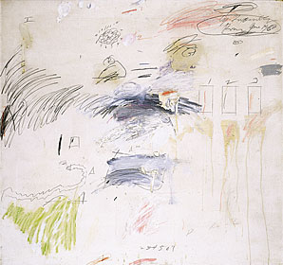
No. Remember that the relationship is one of unity and complexity. Not understanding is not going to do that by itself – it would be chaos, a mess, just anything. The puzzle of a Pollock or a Twombley isn’t the mess, it’s that it seems somehow unified in ways that cannot be cashed out by merely pointing to the structure of the piece.

Question: [inaudible]

There are different ways of doing aesthetics. Benjamin said, let’s stop talking about aesthetic experience and start talking about aesthetic production. As far as that goes, Kant doesn’t care about all the agonies the artist went through etc., he’s only interested in the product. That it was accidental, intentional, doesn’t matter. All that matters is what’s on the canvas.

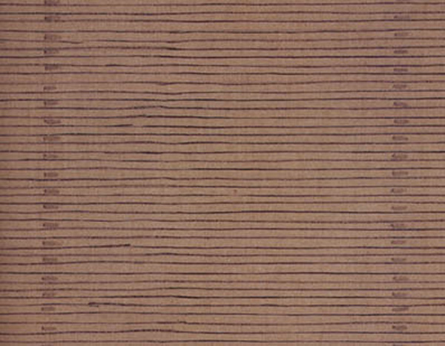
The mystery and fantasticness of Agnes Martin is that she ought to be the very exemplary case of playing in order. And somehow it’s not that. And to figure out why it isn’t – why her works are not merely geometric grids – and why we experience in them a non-geometrical purity, like an austere spiritual exercise… there’s something hypnotic about it.

Question: Can a person be beautiful?

We’re getting there. It’s called the ideal of beauty. Let’s see if we can start that discussion.

43:45

There are still problem cases here. Think of the great monochrome works of art. Robert Riman is one of the most complex artists around. As rich and complex as a renaissance artist. I don’t think I want to say that about an Yves Klein or Ellsworth Kelly. My view is Kelly is abysmal. Something in the area of the above discussion is at stake there, though I don’t know how to negotiate that.

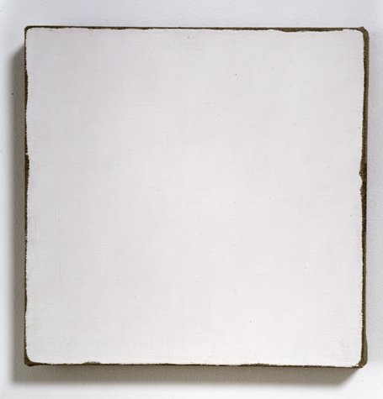
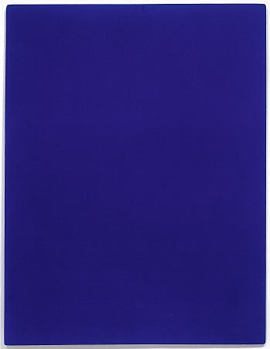
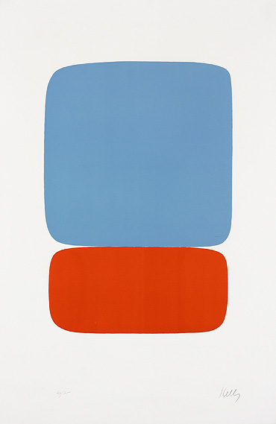

Riman Klein Kelly

§15 is Kant’s critique of rational aesthetics, according to which things are beautiful if and only if they are perfect, and aesthetic cognition of them is a sensory apprehension of something (rationally) perfect in itself, where perfection refers to what sort of thing an object is meant to be. This was the dominant aesthetic view at the time.

§§16, 17 address the problem of conceptual content, and thereby, impure judgements of taste. He does so by drawing a contrast between pure or free beauties and adherent or dependent (conditioned, accessory) beauties.

On pp. 229-30 Kant defines these terms:

When we judge free beauty (according to mere form) then our judgement of taste is pure. Here we presuppose no concept of any purpose for which the manifold is to serve the given object, and hence no concept as to what the object is meant to represent; our imagination is playing, as it were, while it contemplates the shape, and such a concept would only restrict its freedom.

The use of Latin terms here shows Kant’s nervousness. The Latin gives a false precision.

pulchrituda vaga
pulchrituda adheris

Vaga is a strange Latinate term to pick up. Matthews, in his commentary, that it has the sense of wandering, roaming, diffuse, stolling about, unfixed, aimless. The term “aimless” is perhaps the most revealing since it reveals the absence of a determinate purpose. This fits nicely with Kant’s examples in §4, namely “Flowers, free designs, lines aimlessly intertwined and called foliage” – the words “doodles” and “doodling,” used in reference to aimlessly drawn lines also capture this idea to some extent. Rendering free beauty as “doodling beauty” would be linguistically unattractive but does capture much of the sentiment of vaga.

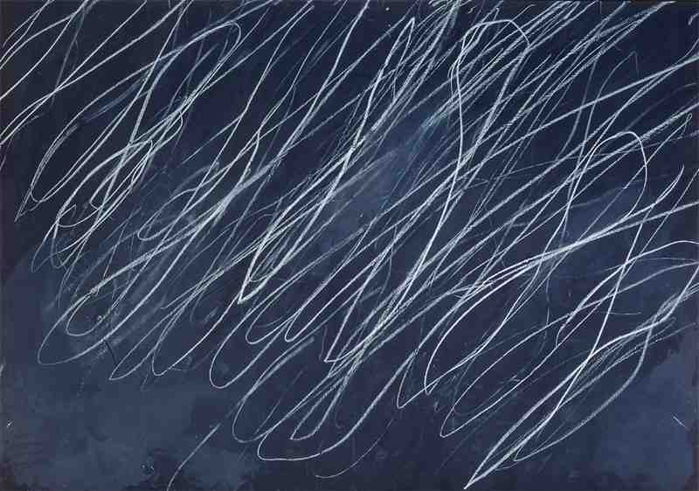
That’s why I said, if you want to think of free beauty, think of Cy Twombley. He uses combinations of childlike scribbing to de-skill and disorder the painting’s surface. He wants to use, as it were, pre-drawing, precisely because the notion of drawing has become associated with order and regularity. So to return drawing to the state of excess of form, he scribbles and doodles. For years I didn’t get Twombley. But what is interesting, part of what makes his art possible, is that in the forty-odd years he’s been painting, he’s never developed. There are phases – he does it on blackboards, and then on canvas – but the intrinsic nature of the Twombley practice has not developed, and it could not develop without undercutting his own discovery about scribbling – that scribbling has to be in accessible to development in order to make it work. So now, the fact that he never developed a second stage, looks to me like genius.

This distinction between pure and adherent beauties can be puzzling, although it is part of what has often led to Kant being associated with high modernism of painterly abstraction. That abstraction seems exactly like what a free, wandering aimless beauty would look like.

Hence Kant’s famous two lists:

List of free beauties

On p. 229 he says,

Many birds (the parrot, the humming-bird, the bird of paradise) and a lot of crustaceans in the sea are [free] beauties themselves [and] belong to no object determined by concepts as to its purpose, but we like them freely and on their own account. Thus designs à la grecque, the foliage on borders or on wallpaper, etc., mean nothing on their own: they represent [vorstellen] nothing, no object under a determinate concept, and are free beauties.

i.e. he takes the opposite of high art – decorativeness – and uses it as a clue to the notion of pure beauty. (That’s also what Matisse did – he put decorativeness back into painting – but by doing that he meant to make painting really difficult, since it is the hardest thing rather than the easiest thing.)

List of adherent beauties

Page 230:

But the beauty of a human being (and, as kinds subordinate to a human being, the beauty of a man or woman or child), or the beauty of a horse or of a building (such as a church, palace, armoury, or summer-house) does presuppose the concept of the purpose that determines what the thing is meant to be, and hence a concept of its perfection, and so it is merely adherent beauty.

There are certain types of objects where we cannot abstract from their purpose when we see them. Either these objects can never be beautiful, or their beauty is somehow related to their purpose. The question is, how can we relate the beauty of an object to its purpose without having the purpose subsume the beauty and collapse backwards into perfectionist aesthetics?

This is all the more the case if we are tempted to say (as Kant is) that the paradigm case of all beauty is the beauty of the human.

