November 28, 2007

THE SUBLIME (ctd.)

We left off last time discussing p. 245, where I had already talked about the phrase

For the one liking ([that for] the beautiful) carries with it directly a feeling of life’s being furthered, and hence is compatible with charms and with an imagination at play. But the other liking (the feeling of the sublime) is a pleasure that arises only indirectly: it is produced by the feeling of a momentary inhibition of the vital forces followed immediately by an outpouring of them that is all the stronger.

So a pleasure in our being afraid or anguished or disturbed, and then an overcoming of that disturbance – a framing / controlling / sublimating of it, in some way. Kant will give a naïvely easy answer to the question of that pleasure. But we will question whether his sense of the pleasure in the sublime is as directly straightforward as all that.

Kant goes on to say

Hence it is an emotion,

I hesitate only because feelings and emotions are different things, and Kant is collapsing them here. But he seems aware that something else is going on – that pleasures are usually taken to be immediate feelings; emotions, just to be clear, are usually taken to be intensional – that is, they have an object, and a structure, they can be appropriate or inappropriate. So calling it an emotion is already acknowledging the weight of reflection involved in this feeling – that it may indeed be closer to an emotion than an outright feeling, in a way that the harmony of the faculties could legitimately be thought of to be – just a feeling.

Something about the pleasure here, therefore, is problematic. And he says:

Hence it is an emotion, and so it seems to be seriousness, rather than play, in the imagination’s activity. Hence, too, this liking is incompatible with charms, and, since the mind is not just attracted by this object but is alternately always repelled as well, the liking for the sublime contains not so much a positive pleasure as rather admiration and respect, and so should be called a negative pleasure.

How do you like that for an oxymoron? What is a negative pleasure? And why, and with what license, does he automatically think he can get admiration and respect in here? All of this needs unpacking.

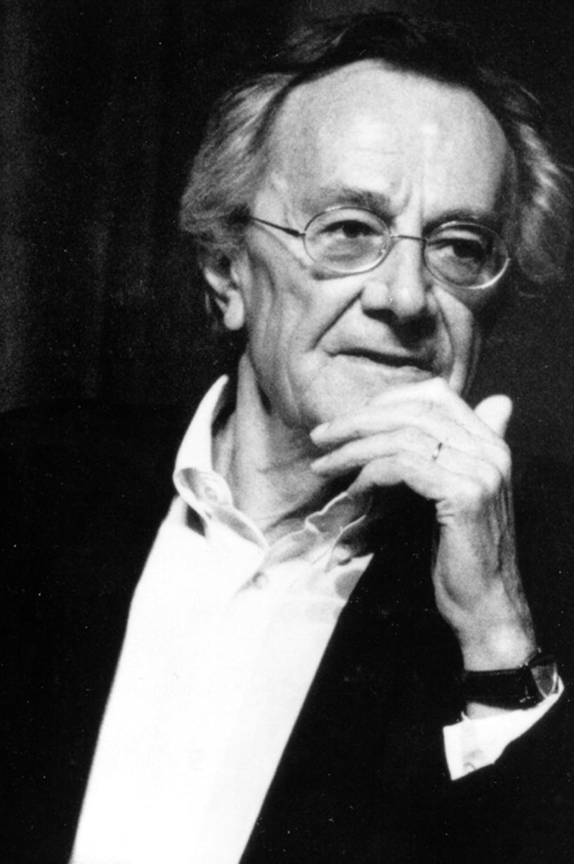
Lyotard looks at this moment in a slightly peculiar way. He looks at the notion of the seriousness rather than the play. He wants to get from the beautiful to the sublime, and therefore his first gesture, which does not follow Kant, is to imagine the imagination itself proliferating its forms, or as he puts it, “going wild,” as it does in the work of art, that is, in the work of genius. Genius is the proliferation of forms. Lyotard says that this overabundance of images, this proliferation of forms by the imagination gone wild, makes up for this powerlessness of principle – powerlessness to create a whole. But then, creativity is no longer in free play, pleasant, even fortuitous. It falls prey to a regime of anguish.

Why anguish? Lyotard says, “This must be understood in the seriousness with which Kant qualifies the activity of the imagination in the sublime. It is the seriousness of melancholy.” Why melancholy? Because imagination here is suffering from an irreparable lack, an impotence, an inadequacy. What it is missing is an absolute nostalgia for forms only always being forms – that is, limitation. It is the experience of the relationship between the limited and the unlimited. “Even as it deploys an unlimited field of proliferating forms, before thought, the imagination remains a slave to its finitude because each of the forms it invents and adds to the others remains limited by definition.” That is, in the experience of the sublime we are in the area of seriousness because we are in the area of acknowledging our finitude, because the imagination is always brought up to the fact that it can only have finite forms, so no matter how many it has, it’s stuck with that finitude and has to acknowledge it. And acknowledge that finitude is in some way inadequate.

So finitude here is a privation, and remains privative throughout the sublime.

Question: Kant wanted to say that what is revealed to us in the sublime is our own infinitude.

Of course. But the question that Lyotard is raising is why, even though the sublime is an aesthetic thing, Kant suddenly drops the notion of play and insists on seriousness. Up until now it’s all been about harmony, and free play, and getting in touch with nature. Now there is seriousness. Lyotard is arguing that Kant is using that language because something about finitude is going to prove insufficient. When Lyotard says melancholic, he means finitude is experienced here as absolute loss. So, we may find an infinity to balance it out, but the finitude itself, if we are going to take the notion of anguish or pain seriously, has to be roughly at that level. It’s getting the right weight into the notion of the moment of pain in the sublime.

The problem of pleasure is going to be hard by itself, but the first issue is that Kant is emphatic that as an aesthetic phenomenon, the sublime has a structure of pain and pleasure. And therefore, whatever the moment of the negative is here, negative feelings, those negative feelings have to be more than “Oh, I can’t do it.” For those feelings we have all the time.

So, we need to find some motivation for the language of pain and anguish, being repelled, that Kant uses.

The notion of negative pleasure is important because one of the questions you should be asking yourself (I’ll come back to §27 where he has the phenomenology of the feeling) is whether the feeling of the sublime is one complex emotion, or an alternating series of emotions, of pain followed by a pleasure. At least here, in coining it a “negative pleasure,” he seems to be thinking of it as one complex pleasure.

The big disanalogy between beauty and the sublime, which he mentions at p. 245, is that while beauty is purposive for the power of judgement, the sublime is contra- purposive for the power of judgement. As he puts it

incommensurate with our power of exhibition, and as it were violent to our imagination, and yet we judge it all the more sublime for that.

So, the more contra-purposive, the more violent, the more humiliation we suffer, the happier we are.

Now, all that said, as I mentioned last time, Kant then withdraws by mentioning that there is nothing sublime in nature. That, properly speaking, the sublime belongs not to nature but to the mind. So, p. 245 still

Instead, all we are entitled to say is that the object is suitable for exhibiting a sublimity that can be found in the mind. For what is sublime, in the proper meaning of the term, cannot be contained in any sensible form but concerns only ideas of reason, which, though they cannot be exhibited adequately, are aroused and called to mind by this very inadequacy, which can be exhibited in sensibility.

So it’s the experience of the imagination, which is to stand in for sensibility as a whole, suffering some humiliation or violence as it attempts to grasp some natural scene. And in its failure to do so, there is put in mind (we’ll see the putting in mind actually happens earlier) that even though we cannot think of the object as infinite, we come to recognize an infinity in us – that is, ideas of reason here, ideas of the unconditioned, or if you will, ideas of the absolute, which themselves, qua ideas, could never be exhibited.

Thus the vast ocean heaved up by storms cannot be called sublime. The sight of it is horrible; and one must already have filled one’s mind with all sorts of ideas if such an intuition is to attune it to a feeling that is itself sublime, inasmuch as the mind is induced to abandon sensibility and occupy itself with ideas containing a higher purposiveness.

So there you are, looking at the roaring ocean, and now you are to turn away from it somehow, and occupy yourself with the ideas of reason. I could never quite figure out how the mind does that.

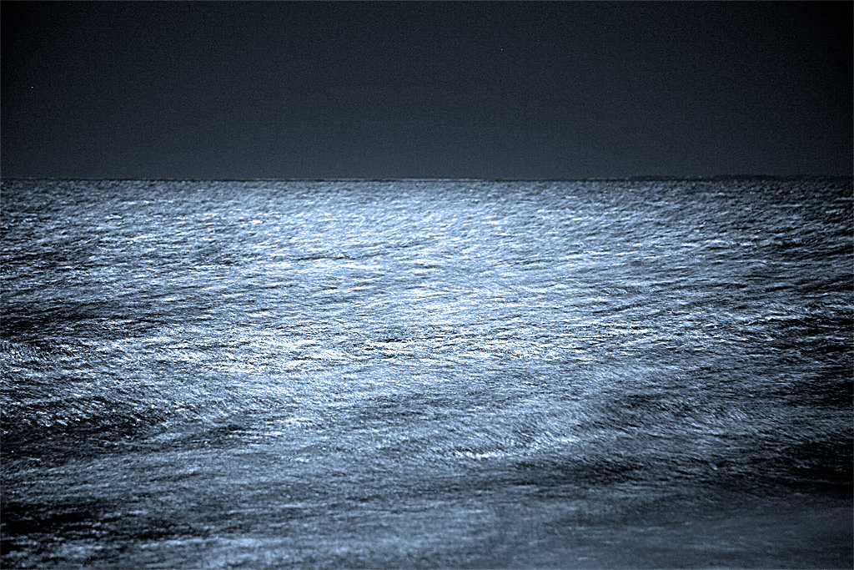

The point I would like to underline at this juncture is that it is evident here that we are getting an opposing conception of the natural world than we one we got when we looked at the question of the beautiful. There, we examined the natural world as an appropriate habitat for human beings – something we were attuned to, something we had our natural place in and were a part of and were continuous with.

The view of nature in the sublime is just the opposite. Nature, in the instance of the sublime, is primordial nature. That nature which is threatening to human beings, which primitive human beings were terrified of and gave godlike names to. And the structure of the sublime, in Kant, is really at least in part a part of this primitive battle between the human being and the natural world.

Someone who understood this perfectly, and who provided a kind of caricature of the Kantian view of the sublime is Schiller, in his great essay on the sublime. So what is done, as it were, behind the scenes in Kant is done wide open and crudely in Schiller.

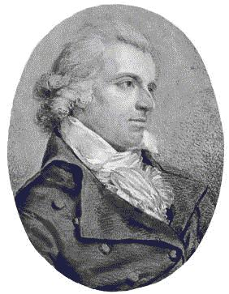
Schiller views human beings as surrounded “by numberless forces which are superior to him and which hold sway over him.” And we undertake all sorts of efforts to control threatening nature. And indeed our intelligence – our understanding – is indeed the attempt to control and manipulate nature, to dominate nature, in order to bring it into harmony with our natural needs. And to a certain extent, Schiller says, we succeed in reigning physically over everything that is physical. Let’s call that technology.

But still, Schiller says, “man’s efforts inevitably founder,” and they founder because we can never overcome death. Death is the single point where a human being is under constraint and bound. Now, “it is at this single point,” says Schiller, “that the human being boasts his liberty.”

So, for Schiller, the human being, properly understood, is irreconciliable with succumbing to any exterior force:

He must be man in the full sense of the term, and consequently he must have nothing to endure contrary to his will. Accordingly, when he no longer can oppose to physical forces and proportional physical force, only one resource remains to him to avoid suffering any violence. He must annihilate, as an idea, the violence he is obliged to suffer in fact.

What he means by that is that we are capable of doing so because we are moral beings. And as moral beings, we participate in a higher order than the natural order. And indeed, following Kant absolutely, Schiller thinks of this higher order as the moral law itself, that is, the law of freedom.

So, Schiller says,

Man is in the hands of nature, but the will of man – his power of freedom – is in his own hands.

So, the sublime, for Schiller, is a sensuous means to teach us that we have something more in us than a sensuous nature.

Here, the physical man and the moral man separate in the most marked manner, for it is exactly in the presence of objects that make us feel at once how limited the former is [that is, the physical man] that the other [the moral man] makes the experience of its force. The very thing that lowers one to the earth is precisely that which raises the other to the infinite.

One of the reasons that Schiller is interested in the sublime – and the question is why are we interested in the sublime – is because he thinks that ordinarily, we tend to forget our moral vocation. We forget our superiority to nature in having this purely rational power within us. And part of what makes us forget this is indeed the beautiful. The beautiful is a kind of seduction that leads us to think that nature might be friendly, that the world may be okay, that we can get on with life in a sensible way, and in feeling the beautiful, we think of ourselves as in mutually dependent relationships with nature. And are satisfied by that.

This is illusory, for Schiller. He says,

It is not little by little, for between absolute dependence, and absolute liberty, there is no possible transition. It is suddenly, and by a shock, that the sublime wrenches our spiritual and independent nature away from the net which feeling has spun around us, and which enchains the soul more tightly because of its subtle texture…

One single sublime emotion often suffices to break all this tissue of imposture [the imposture is beautiful spirituality], at one blow, to give freedom to the fettered elasticity of spiritual nature, to reveal its true destination, and to oblige it to conceive, for one instant at least, the feeling of its liberty.

So the thought here is of an absolute incommensurability between our moral powers and our habitation of the natural world – no transitions are possible. And the sublime is going to be a moment in which we come face to face with our physical standing in the world, and are wrenched out of it in order to feel an absolute liberty. Remember that this is being written at about the time of the French revolution – absolute liberty, absolute freedom, absolute terror – all of these are lurking around in this notion of this lack of mediation between nature and freedom.

Why is he insisting in the incommensurability here?

The insistence comes in exactly the same way as it came in Pascal: I may be an infinitely small speck in a physical universe, but I am one that is capable of comprehending that whole, and am therefore in every sense beyond it. So this is that moment when rationality is trying to come to grips with the meaning of a joint discovery – and I think it is important to think of this moment as terribly fraught in the history of ideas, one which I would argue we haven’t thought through yet, namely, that we live in a disenchanted physical universe, on the one hand, and that we have discovered our powers for historical creation, on the other. That we are free, self-determining agents. And for Kant – and I take it this is part of why he thinks the story of the sublime is important – the sublime is that moment in which those two things are experienced. Not just thought, but experienced.

So part of the depth of the sublime is that it brings us to that pitch of, not contradiction, but aporia in the modern situation, of the modern subject. That’s how Kant would think it. And the sublime, for him, is that lesson of that experience of that aporia.

Question: Is the sublime also part of Kant’s late-stage importing of morality into the Critique? Was this added as part of that third stratum?

Yes. And Kant is trying to domesticate it. In his earlier writings on the sublime – his essay Observations On the Beautiful and the Sublime, there is this (remarkably sexist) passage where, roughly, guys are sublime and women are beautiful. There is this whole gender language that deals with education. So he already tries to domesticate it there, in that way, but he hadn’t really hit on his whole theory yet.

Kant is trying to contain the sublime. Burke is merely psychological, so it’s hard to know what is going on in Burkean analysis. But for Burke, it is nature that is sublime, not reason within us. And it’s natural for us to think – we do think, still, despite Kant – that it’s the alps that are sublime, or the starry heavens. Kant thinks that is subreption. That is, he thinks we are projecting onto the object an infinity that is only proper to the subject. And that is his way of trying to contain it.

Now, part of the reason he does so, even though I think it is a containment strategy, is because having thought about Burke’s psychology, he can’t figure out where the pleasure is going to come from. So Kant, at least, unlike Burke, is trying to answer the question why we feel pleasure in this. So in that sense the details of the account do matter, because of Kant’s phenomenology of the experience of trying to come to grips with the way in which this involves both negative and positive emotions or feelings.

Let us talk about the mathematical sublime.

You can get really lost in the mathematical sublime. I will try to keep to the core arguments as far as possible.

In §25, he defines the sublime as absolutely large. And what is absolutely large is what is large beyond all comparison. The “beyond all comparison” is the crux here, because if it’s not a comparative largeness, that means it’s not measured against anything else. It is without limit. Therefore, it is absolute or unconditioned, to be measured only against itself.

Unfortunately, Pluhar begins his account – his translation of pp. 248-9 getting the distinction between the absolutely great, and the simply great, and then loses it. So the translation is a bit confusing. Allison gives all the details on p. 312. But rough and readily, what is going on on pages 249-9 is not a discussion of the absolutely great, but of the simply great, which Kant is using as a prologue to the absolutely great.

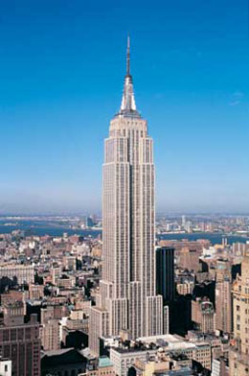
So, let us talk about the Empire State Building. That’s big. Awesome. Now, in making the judgement “That’s awesome,” it appears as non-comparative, but only because we’re not using any explicit measure. But a measure is assumed nonetheless, albeit an indeterminate one, because we do expect others to agree with our judgement. That is, we don’t think it’s a merely relative judgement. Being in a certain position, looking up, “That’s awesome” has got to be right. Now, in measuring it, we are, according to Kant, making an aesthetic judgement. So, the Empire State Building would be, for Kant, sort of sublime.

Well, this way of leading into the mathematical sublime is confusing, because, roughly, an indeterminate concept is not the same as having no concept. Kant assumes that the two are the same. Which tells you a lot about Kant. And therefore, although he thinks we are judging by the eye, we are in fact assuming a rough measure, or an inexact measure, but nonetheless a measure. It’s just that that measure is unmentioned, or suppressed. It is our own bodies. And indeed, the measure of the body will be something that is running throughout all of this – when we look at things in terms of size, there has always got to be a relativity to the body, and of course the powers of the body.

Kant then goes on to suggest, as a brief interlude, that we think of the large as that which is deserving of respect and admiration, and the small as that which is deserving of contempt. Which means that there is a naïve, quantitative affective geometry running through this. (Levinas, likewise, always thinks that you are called from on high.) Why can’t you be called by a small voice? Why can’t you feel admiration for a small speck? I point this out because I do think it is naïve and culturally specific and not natural.

At p. 250, he finally does get to the absolutely great.

Suppose something not only large, but large absolutely. In every respect beyond all comparison – that is, sublime. Clearly, in that case, we do not permit a standard adequate to be sought outside it, but only within it. It is a magnitude that is equal only to itself.

So the absolutely large is a magnitude equal only to itself.

It follows

– terribly important how (mere) definitions slip into big inferences here –

It follows that the sublime is not to be sought in things in nature, but must be sought solely in our ideas. but in which of these it resides is a question that must wait for the deduction.

His thought here is that if you choose any physical object as a measure, no matter how large – lightyears, etc. – they’re nonetheless going to be comparative. Therefore, anything you can find in the natural world is going to fail the definition of being absolutely large, and hence necessarily, the argument is going to run, what is absolutely large is going to have its measure only in itself, and so cannot be anything physical.

He then goes on to rub it in:

That is the sublime, in comparison with which everything else is small.

he then takes the next step

We can easily here see easily see here that nothing in nature can be given, however large we may judge it, that could not, when considered in a different relation, be degraded all the way to the infinitely small.

Now, the way in which this works – the reason why this is required – is that there is a relationship, in this business of figuring out the right measurement, between the imagination and reason. Such that the object is going to bring the imagination to count it. And it can just keep on counting. What it cannot do is divide totality. With that activity of counting, we always want to totalize it into an absolute whole. Reason is commanding the imagination to totalize its infinity – to bring it into a single intuition. And it will be the imagination’s failure to do so – not absolutely (the imagination itself is just happy to keep counting), but only with respect to that requirement of totalization – that will give onto reason, not as sensible, but as supersensible. And reason as supersensible is that, in comparison with which, all else is small.

That is the logic, and that is what he says in the following three sentences, which I shall paraphrase:

What happens is that our imagination strives to progress towards infinite, while our reason demands the absolute (demands totality) as the real idea. And so the imagination, which registers magnitudes in the world of sense, is inadequate to that idea.

So it fails to take counting into a single intuition, a single whole. There is also a problem of taking what is temporal and turning it into a simultaneity. Reason wants to transcend time itself. Reason is doing a violence to inner sense.

Yet this inadequacy itself is the arousal in us of the feeling that we have within us a supersensible power. And what is absolutely large is not an object of sense, but is the use that judgement makes naturally of certain objects so as to arouse this feeling, and in contrast with that, any other use is small.

So in a way, reason is using the supersensible to arouse the feeling of the smallness of the physical universe. So the sublime is what, even to be able to think, proves that the mind has a power surpassing any standard of sense.

Now, in §26, he tries to take this logic and tie it down in a more complicated way. He calls this moment apprehension, and this moment comprehension. And then he is going to say apprehension is the collecting up to infinity, comprehension is the holding together of what is collected. When comprehension fails – and he says it fails when, say, you are looking at the stars, and you get to 3,487, and you start losing the first stars – when the comprehension fails by the beginning dropping out, a maximum is then recognized, and the imagination is exceeded. I just simplified a really complicated bit of argument.

So, he says, p. 254

Hence reason demands comprehension in one intuition, and exhibition of all the members of a progressively increasing numerical series, and it exempts from this demand not even the infinite (space and past time). Rather, reason makes us unavoidably think that the infinite (in common reason’s judgement) as given in its entirety (in its totality).

So, this is an argument that is not unlike the Antinomies of Space and Time in the First Critique where, in terms of the phenomenal world, we need counting, but in terms of the noumenal world, we can think of space and time as an absolute whole.

***

It is an oddity of Kant’s account that while he says nature is the proper locale of the sublime, he illustrates this with discussions of St Peter’s and the pyramids. I take these illustrations not to be cases of the sublime as such, but as meant to illustrate how apprehension and comprehension work in these cases.

There is a primacy of nature here because art is always purposive, hence unsuitable for thinking the sublime. The sublime, he says, must have no purpose whatsoever of the object, as the basis determining it.

The crux of the mathematical sublime is the necessity of thinking the infinte.

Carrying on reading p. 254

The infinite, however, is absolutely large. Compared with it everything else is small. But to be able even to think the infinite as a whole indicates a mental power that surpasses any standard of sense. For [thinking the infinite as a whole while while using a standard of sense] would require a comprehension, yielding as a unity a standard that would have a determinate relation to the infinite. one that could be stated in numbers; and this is impossible.

Any number is going to be too small because you can just keep adding to it.

If the human mind is nonetheless able to be able even to think the given infinite without contradiction, it must have within itself a power that is supersensible

that is, detachable from the powers of the imagination. And that is the same argument that Descartes uses in the second Mediation when he is asking what is the nature of sensible objects. He says, they are malleable, they can take infinitely many shapes – but if that is the case, then our idea of an object is a rational idea. That is, something not known through the senses.

whose idea of a noumenon cannot be intuited but can yet be regarded as the substrate underlying what is mere appearance, namely, our intuition of the world.

Allison states this argument in the following terms (p. 323)

Sublime objects – objects that are tied up with the feeling of the sublime – cannot be held within a single intuition. They objects present themselves to the imagination as if absolutely great.

But to do justice to this (my experience of the starry heavens as infinite, therefore absolutely great), the imagination

seeks to produce a unit of measure adequate to the task. But the only possible measure would be the whole of nature.

Which is to say, the unconditioned. And that notion of the unconditioned is contradictory because nature, as an absolute totality, we experience only in terms of an infinite progression. So even the idea of nature as a totality is insufficient as a measure.

Kant’s thought is that the feeling produced by the mental attunement involved in entertaining the idea of the supersensible, occasioned by objects via the mathematically sublime, he says, conforms to, or is compatible with, our moral feeling. That is, our sense that we have the supersensible within us – that we are more than sensible creatures.

[8:10]
He uses the phrase “conforms to” or “is compatible with” moral feeling because he does not want to say it is a moral feeling, because it if were, it would not be an aesthetic response, but a moral response. It is an aesthetic response because it lacks any motivating force. It doesn’t determine the will in any particular way, the way the moral feelings do.

What Kant is demanding here, as he does elsewhere, is a difference between experiencing and thinking – in the First Critique, it was a difference between knowing and thinking; here, the difference is between aesthetically estimating and thinking. But in both cases, we are pushed to recognize in ourselves a non-sensible capacity.

When Kant talks about art, he does so in terms of aesthetic ideals. These are sensible corollaries of intellectual ideas, which are the same as moral ideas. The question is, what are aesthetic ideas?

Question: Kant is burying something when he links the imagination just to the sensible – in the First Critique, there is a spontaneous side of the imagination.

The imagination is always just going to find another form. It’s partially sensible, remember, but it’s always about exhibition, presentation. The imagination may be spontaneous in all sorts of ways – call that its freedom – but it will always be bound by the sensible. The infinite is never going to be a sensible idea.

Once we realize that something could take an infinite number of shapes, we have stopped imagining and started reasoning.

So the feeling of the imagination is going to have another sort of role. We will come back to this in the discussion of genius.

Let’s press on to the phenomenology of sublime feeling (§27), and the dynamical sublime, which is more interesting and more plausible.

The crucial feeling, perhaps disappointingly, is that of respect:

the feeling that it is beyond our ability to attain to an idea that is a law for us is respect

The moral law is

- the law of our will
- an ideal with normative authority.

It always stands above us, remains a norm, and authoritative for us. We can asymptotically approach it by trying to conform to it, but we can never attain it. Hence the feeling of respect for it.

The idea of normative authority is what is doing a lot of the work here. Something can only have normative authority if it is lawlike: always independent of your will, and a guide for it.

That’s our idea of reason and the supersensible in us. It’s respect for our own vocation because it’s respect for the fact that we are rational self-determiners. That is, we have the power to act in accordance with norms.

This notion of ideality is incommensurable with any sensible presentation, because any sensible presentation will not be it, not an instance of it with respect to its authority. It’s the authoritative character of something that is normatively ideal, that is, authoritative for the will, that is doing the work here. And that, for Kant, is our reason. Reason is our capacity to be moved by pure idea.

So the notion of respect is the thought that we are intrinsically motivated by our apprehension of this to act in accordance with it.

We also – just to remind you – have another spring of motivation: desire. Like the little devils on either shoulder: moral law here, sensibility there.

Respect is that feeling in relationship to that rational authority.

So the sublime feeling is a feeling that refers to that rational vocation, and a rational vocation that means that we are not to be determined or governed by anything sensible. That ultimately, our actions are to be determined by the moral law itself, hence by reason itself.

27:50

This is why Kant thinks of the notion of the sublime as a subreption – that is, we think we are respecting nature, but really it is our own rational vocation, although certain objects are capable of occasioning such a feeling.

This is the big difference between the beautiful and the sublime. In the case of the sublime, the object is an occasion which sets off in me my coming to awareness of my rational vocation, and certain objects are more or less suitable for doing that (say, the starry heavens). But I want to underline the thought that the object is an occasion, which means that the object almost drops out. The object has a less intrinsic role to play, and it’s because of that that Kant feels he does not have to offer a deduction of the sublime. After all, what would a deduction of the sublime be? The object is an occasion for me being aware of what I am rationally. Things I possess anyway. Then all I have to do is explain or elaborate situations in the right way, and the sublime is justified, it’s deduced. The appropriate feeling is just the pain, pleasure. And it turns out the pleasure itself is a pleasure in what we can already feel good about, namely that we are rational self-determining creatures. Hence Kant says that there is no deduction of the sublime. Its exposition is the same as its deduction.

Kant gives a variety of curious descriptions of the actual feelings themselves. At 258, he says

In presenting the sublime in nature, the mind feels agitated, while in aesthetic judgement of the beautiful in nature, it is in restful contemplation. This agitation, above all at its inception, can be compared with a vibration, i.e. with a rapid alternation of repulsion from, and attraction to, one and the same object. If a thing is excessive for the imagination, the imagination is driven to an excess as it apprehends the thing in intuition, then the thing … an abyss, in which the imagination is afraid to lose itself. Yet at the same time… to mere sensibility.

On the next page, he talks about the simultaneity, which is to say Kant seems to give two different descriptions of the sublime feeling. On the one occasion, he thinks of the sublime feeling as one complex feeling in which the imagination is humiliated, and in the same experience, we feel this excessive pleasure. A second version of the sublime is presented as a series of individual feelings in which first the imagination feels pain, then there is some sort of rational insight, and then it feels pleasure.

In his article on the sublime, Guyer plausibly argues that the reason Kant is tempted by the second account – the serial account – is because he is very often persuaded by Hume’s theories of feelings. And for Hume, feelings (especially of pleasure) have to be atomic and unmixed. And there is a way in which Kant is often inheriting empiricist ideas, and then trying to do things with them that they can’t quite manage. Kant here wants to talk about a complex emotional experience that has these cognitive dimensions, and his inclinations towards empiricist accounts of feelings and emotions leads him to oversimplify.

37:45

So if you want to think about the sublime feeling, it’s probably more plausible if one tries to construct it as he does at the beginning – a negative pleasure. A feeling that is bound up with an experience of the negative being surmounted, as a component of that feeling.

Q: Does Kant, like Hume, mean pain in the sense of discomfort and uneasiness?

A: That, yes, and he also describes humiliation, and violence in the experience of limitation.

It is also worth remembering that the moral law itself – the notion of respect for the moral law – is complicated, and in fact contradictory. The contradictoriness is kind of obvious. The moral law has to do two tasks, affectively. It has to humiliate the desires – it has to humble us – and it has to represent an ideal to be striven after. So it actually goes in two different directions: one direction is the hammering of the desires, and the other is presenting itself as an object of ideal fascination. Which is to say, if you are a Freudian, it is both a superego (“don’t do this,” “don’t do that”) and an ego-ideal (that which you want to be). If you think hard about it, Kant can’t really account for the double structure of the moral law, but I mention it here because the experience of the moral law includes both the pain of humiliation and the pleasure of desire. The notion of respect in fact encapsulates itself a complicated pleasure-pain structure. That is my claim, and my hunch that it was because Kant intuitively had that thought of that the moral law does that he found it so easy to paste it onto the structure of the sublime.

§28 THE DYNAMICALLY SUBLIME

This is the sublime we’re more familiar with, but also the sublime in ways that raises all those questions we’ve been skirting around. This considers nature, not in terms of quantity but in terms of quality, and in particular in terms of might, in terms of the power of nature.

Now, in aesthetic responses to large mountains and roaring waterfalls and other sites of the dynamically sublime, we are overawed, but we cannot be literally afraid, for an aesthetic response would then be impossible. When we’re afraid, we’re not going to appreciate anything; we’re just going to run.

Here is the puzzle: it is the experience of nature as fearful, without actually being afraid. Now, what separates actual fear from what I’m calling the fearful is that in the perception of a true object of fear, one would be aware that any resistance would be futile. Which is to say that in seeing something as truly fearful, we have to recognize our physical impotence. What makes an aesthetic perception of all this possible is that we experience this might from a safe place, a safe distance.

So, Kant says, p. 261

On the other hand, consider bold, overhanging and, as it were, threatening rocks, thunderclouds piling up in the sky and moving about accompanied by lightning and thunderclaps, volcanoes with all their destructive power, hurricanes with all the devastation they leave behind, the boundless ocean heaved up, the high waterfall of a mighty river, and so on. Compared to the might of any of these, our ability to resist becomes an insignificant trifle. Yet the sight of them becomes all the more attractive the more fearful it is, provided we are in a safe place. And we like to call these objects sublime because they raise the soul’s fortitude above its usual middle range and allow us to discover in ourselves an ability to resist which is of a quite different kind, and which gives us the courage [to believe] that we could be a match for nature’s seeming omnipotence.

So aesthetic distance from nature is distance from its immediate threat. But what is so viewed is nature in its immense power and in its indifference to us. That is, what we become aware of, in this case, really is nature is an utterly disenchanted and terrifying place, and hence what we become aware of is our mortality, and thereby our finitude.

Now, physical nature is necessary but not sufficient for Kant because our physical independence from this threat gets translated into a moral independence from nature, so he says, at the end on p. 261

In the same way, though the irresistibility of nature’s might makes us, considered as natural beings, recognize our physical impotence, it reveals in us at the same time an ability to judge ourselves independent of nature, and reveals in us a superiority over nature that is the basis of a self-preservation quite different in kind from the one that can be assailed and endangered by nature outside us.

I take it our capacity to preserve ourselves as moral beings.

At the very last paragraph of the section, he says:

Sublimity is contained not in any thing of nature, but only in our mind, insofar as we can become conscious of our superiority to nature within us, and thereby also to nature outside us (as far as it influences us). Whatever arouses this feeling in us, and this includes the might of nature that challenges our forces, is then (although improperly) called sublime. And it is only by presupposing this idea within us, and by referring to it, that we can arrive at the idea of the sublimity of that being who arouses deep respect in us, not just by his might as demonstrated in nature, but even more by the ability, with which we have been endowed, to judge nature without fear and to think of our vocation as being sublimely above nature.

This is puzzling, but the puzzle here I think is deeper than the puzzle with respect to the mathematical sublime, because I think we’re all aware of this nature of the sublime, and somehow the Kantian account approximates something without quite being satisfying. And I want to offer two hypotheses about the nature of the dynamical sublime to try to account for this.

The puzzle is, why do we seek to put ourselves in relation to things that terrify us? What is that about?

I want to answer this in the first case by drawing an analogy between the dynamical sublime and tragedy. After all tragedy, at least according to Aristotle, has a pity/fear catharsis structure, which I want to claim is analogous to the pain/pleasure structure of the sublime. And I find it more than interesting that at the time that the sublime arose, tragedy had almost disappeared from European literature. There was drama, but no tragedy.

So let us start with the question, Why do we go to tragedies? The response I find the most compelling is the one offered by Jonathan Lear in an article on catharsis that appears in Amelie Rorty’s reader on Aristotle’s Poetics. Lear says that normal, educated people, in normal circumstances, and outside of the theatre, seem to have beliefs they do not feel. We all have numerous beliefs we hold intellectually but not affectively, for example we don’t live in constant dread that we are going to die. If we have children, we believe that they are vulnerable, but we can’t live in perpetual anxiety about that. We have lots of beliefs for which we do not have the appropriate feelings. Lear’s hypothesis is that when such people experience a good tragedy, they are able to unify their beliefs with the emotions appropriate to them. I want to argue that this thought extends beyond tragedy to much of art. That is, much of art is about the reconnecting of our cognitive/doxic life with our affective life.

Now, what makes it possible for us to do this is being in a safe place in the theatre. In the theatre, what a dramatist can do, is take states of affairs that would generate the appropriate emotions and treat them as if they were real, or at least possibly real. In a good tragedy, Lear says, “Even if tragedy does not befall us, it goes to the root of the human condition that it is a possibility we must live with.” So the sorts of situations that are rehearsed in tragedies are ones that are related to some of our fundamental beliefs about who we are as human beings. And they take those beliefs and give us the opportunity to experience them.

“Catharsis occurs,” according to Lear,

when we feel we have experienced the worst, in reality or in imagination, and survived. Our survival, which is guaranteed when we have experienced the worst only imaginatively, is what commits the release of our pent-up emotions. Having survived, and appreciating our survival, we have nothing further to fear. There is, Lear says, consolation in realizing that one has experienced the worst, there is nothing further to fear, and yet the world remains a rational and meaningful place in which a person can conduct himself with dignity. Even in tragedy, perhaps especially in tragedy, the fundamental goodness of man and the world are reaffirmed.

I don’t think I believe that last bit, but I suspect that Lear probably does, and I think that Aristotle does, which is why I think Lear is saying it.

Nonetheless the catharsis does seem to have something to do with having experienced the feelings appropriate to those beliefs, and experienced that we can survive them. We are drawn to those tragedies, those types of art, in which there is – interestingly, the word pathos in Aristotle is both objective and subjective. Objective pathos is the occasion – the type of structure of situation – that can threaten a subject, and the subjective pathos is the fear and anxiety occasioned by a situation like that. So for Aristotle, there has to be an appropriate situation – the tragedy must be plausible, it must be something that occurs to individuals for the most part – all that language in Aristotle about how the narrative works is really to try to argue for an objective pathos that generates the subjective pathos, the fear and pity.

[59:45]

How about the sublime? Well, like tragedy, sublimity is to be understood as precisely a relationship between an objective pathos – in this case a greatness in size or intensity threatening our sensible being by the measure of our body – and a subjective pathos, namely fear and anxiety. The scene, although dramatic in itself is no longer a drama. Which is to say it’s no longer a series of actions. It is not characters we observe in the sublime, but ourselves.

Nonetheless I want to insist on it being a kind of drama. And we are both audience and hero in one. This is why pity drops out of the formula. We don’t have to pity ourselves. We don’t have to identify with ourselves; we are ourselves. There is no one’s downfall we have to empathize with, however the movement is directly from a safely observed threat to the recognition of rational safety and the catharsis of pleasure.

What happened to the action? Here’s my guess. Just a guess. As in tragedy, I think, in the sublime, we seek out reassurance that the world is a rational place through contrast with threatening nature – a threatening nature that has been mastered and left behind in the emergence of bourgeois society. This is the reason I mentioned Schiller earlier, when I said that he thinks the seduction is beauty. Let’s say the seduction that makes us forget threatening nature is bourgeois society, that in bourgeois society we no longer face nature as a large and threatening thing. Rather, bourgeois society is a kind of world that supports and protects individuals and therefore dulls the need for significant action. The more rational and orderly society is, the less individual action is required to bear the burden of our standing in the world. Indeed, in the modern world, significant action is usually considered the part of situations that are intimate, tactful, a question of manners or stragegy; at any rate, the sort of things you get in a novel. On the other hand, this orderly and rational world is already beginning to feel flat, small, incapable of presenting, in its own terms, anything that might be said to go to the root of the human condition. If you wish, think of what Heidegger calls the world of Das Man, what Mill thinks of the world of hat (?), what Kierkegaard thought of Christendom. Including for Kant: the bourgeois world is a world of imitative rules in which we forget those features of experience that are constitutive of it. As Adorno puts the thought, “The subject’s powerlessness in society is petrified into a second nature which promotes the motor of flight into purportedly first nature.” That is, I think the sublime is the reason why people go into the woods for a hike; the reason that we seek out waterfalls, the reason why, when the hurricane is lashing outside, we go outside into that howling 100-mile-an-hour wind. Why? Because I want an experience that literally goes to the root of my condition as a natural being.

So my thought is that in the case of the sublime, the sublime reaches past the complacent narcissism of the everyday in order to allow us to measure and sense society as a whole, and us in it as composed still of mortal and vulnerable beings triumphing over hostile nature.

So the original sublime, as it’s thought about in Burke and Kant, I believe, was culture’s first attempt, first need to make an attempt, to find a limit to rational order that would reanimate the subject. That is, we desire the sublime that might destroy us as a reminder of our natural mortality, and we want a reminder of our natural mortality not because we want to die, but because we want a reminder of what it is we are alive. We want to be able to feel our sensible aliveness in relationship to the conditions that make it pertinent. We seek the sublime in order to have the feelings appropriate to our beliefs about ourselves as vulnerable, injurable, mortal beings. I cannot think of any other reason why we would seek it out.

Now, Kant wants a more complicated thought. He thinks we want to seek it out because we want reassurance of ourselves as self-conscious creatures. I’ll stop there…

Q: On your account, to what extent would the sublime have to be a solitary experience.

A: I think it would be, which is why I think we’re always disappointed when we go to Niagara Falls – if you’re part of a party with a guide, it doesn’t have the same zing to it. I was in Yellowstone, and the first thing I wanted to do was get off the path.

Q: It seems then like there is a kind of narcissism in the sublime also. All by myself in the woods, which are bigger than me, but I am taking them on alone.

A: Absolutely, I am not denying the narcissism. It is part of the structure of the sublime. I’m historicizing it as a part of a type of response to a particular bourgeois culture, which is a culture of a kind of narcissism.

Q: I want to know about the relationship between the mathematical and the dynamical sublime, and this in relation to the First Critique.

A: On my reading, the mathematical sublime is actually a version of the dynamical sublime. So my sense is that when I am out of the city, and out of the suburbs, and I look at the sky an find it awesome, it’s because I have a notion of immensity, which takes the quantitative as qualitative. So it’s that sense of being exposed to it.

Q: There’s a threat involved in that bigness?

A: There’s a feeling of radical diminishment of me. It’s the threat that Pascal felt on the basis of the new science. But Pascal just got it immediately. I think that in order to get that feeling of living in an infinite universe – we are born into an infinite universe and rarely feel it, it doesn’t have an affective grip. I think the sublime is those occasions when the notion of an affective universe gets an affective grip.

I’m doing the feeling-alive line rather than the moral-grandeur line or the rational-self-assurance line, and I’ll then have to ask how Kant takes what I am taking to be the narrative structure, and translates it into an account of self-reassurance. I have a story to tell about that, but they’re two different stories.

Q: The sublime seems to give us a mirror image of our dual nature (rational finitude). That is very different from the account you just gave: finding a limit to the rational order, and reaffirming a secure finitude that somehow does not require a rationalization. I think there’s a perfectly anodyne response as to why Kant wanted to do it his way rather than yours, which is that he has a dualistic conception of our natures. But on a deeper level I find that unsatisfying: that is, why is Kant keeping rationality in the picture? What does that add?

A: What I’ll try to convince you of next week is actually a story about the emergence of self-consciousness. How can we think of the sublime as a story of the emergence of self-consciousness überhaupt?

